American Foulbrood-Prevention and Control
American Foulbrood (AFB), caused by the spore-forming bacterium Bacillus larvae, is the most widespread and destructive of the bee brood diseases. Larvae up to three days old become infected by ingesting spores that are present in their food. Spores germinate in the gut of the larva and the vegetative form begins to grow, taking its nourishment from the larva. Spores will not germinate in larvae over three days old. Bacterial growth causes the eventual death of the larva. The vegetative form of the bacterium will die, but not before it produces many millions of spores. Each dead larva may contain as many as 100 million spores.
Disease Spread
The disease can spread rapidly throughout the hive. AFB spores are spread by the house bees as they clean cells, removing dead larvae. The house bees then contaminate brood food with AFB spores. In addition, if the dead larvae dry out, a hard brittle dark scale will form which will lie along the lower walls of the cell. This spore contaminated scale is difficult for house bees to remove. If nectar is stored in these contaminated cells, it will be infected with viable spores and soon the brood chamber, as well as the rest hive, can become filled with AFB spores. As the colony weakens from the AFB infection, robber bees may enter and take contaminated honey back to their hives thereby spreading the disease to other colonies and apiaries. Beekeepers also may spread disease by moving equipment (frames or supers) from contaminated hives to healthy ones.
American Foulbrood spores are extremely resistant to desiccation and can remain viable for more than 80 years in honey and beekeeping equipment. Therefore honey from an unknown source should never be used as bee feed, and used beekeeping equipment should be assumed contaminated unless known to be otherwise. Fortunately, honey with AFB spores is safe for humans to eat.

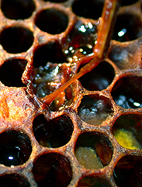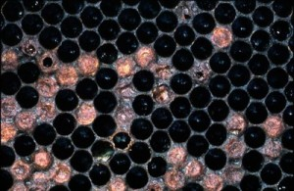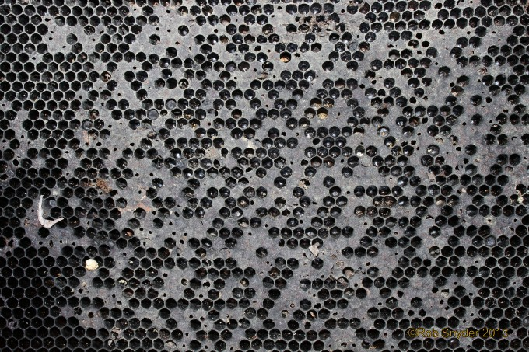
Infected ropey larvae Spotty brood pattern may mean AFB is present Spotty brood in deadout hive
(photo credit: http://www.ars.usda.gov) (photo credit: http://www.honeybeehive.co.uk) (photo credit: Rob Snyder: http://www.beeinform.org)

Management
Terramycin (Oxytetracycline), Tylan (Tylosin titrate), and Lincomix soluble powder (lincomycin hydrochloride) are the only drugs approved for use against American Foulbrood. When present in the food given to susceptible larvae these antibiotics are effective in preventing germination of AFB spores. The bees are then able to develop and mature normally. These drugs will not kill the spores and are not a means for sterilizing either the bees or the equipment. Even if a colony containing AFB spores is maintained in a healthy condition through treatment with these chemicals, the disease may recur when the drug treatment is discontinued.
When purchasing established bee colonies or nucs it is very important to find out if they had been treated for AFB. If they were treated, the purchaser should continue this practice. It is common for inspectors to find AFB in bees that have recently changed ownership and the new owner either by choice or through ignorance discontinued drug treatment.
The Bee Law in Pennsylvania allows for treatment of diseased colonies at the discretion of the State Apiarist. An inspector who finds possible AFB in a colony will take a sample of the diseased brood, explain ways to reduce the possibility of spreading the disease and the possible alternatives to the beekeeper, and send the sample to the PA Department of Agriculture in Harrisburg. The sample will be tested in the laboratory and the results will determine the best method(s) to treat the disease. If the AFB is found in a dead colony (no live bees), the equipment must be burned or buried in a landfill. If the colony is weak or heavily infested, the best alternative may be to kill the bees, scorch the boxes, and burn the frames and combs. If the disease is diagnosed in its early stages and the colony is strong, it may be treated with one of the drugs. Some strains of AFB are resistant to Terramycin and the lab results will report this. A diseased colony treated with drugs should be considered contaminated with spores forever and should be treated preventatively indefinitely. A colony is not cleansed of AFB after treating for a year, two years or even five years. If a colony has had AFB and the drug treatment is discontinued the disease will often come back. Remember to sterilize your hive tools and other equipment with isopropyl alcohol or a bleach solution between yards or even colonies and to wash your bee suit after being around contaminated equipment.
Irradiation of equipment is a way to sterilize your contaminated or potentially contaminated equipment. There are companies that will treat pallets of beekeeping equipment – supers, frames, bottom boards, covers, honeycomb, etc. - with gamma irradiation to kill bacterial DNA. The procedure is safe and effective.

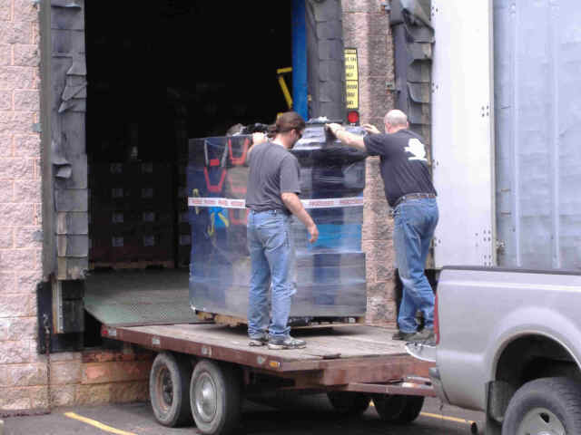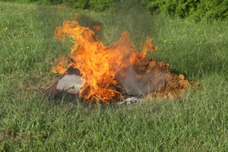
Montgomery County Beekeepers, PA unloading Burning an AFB infected hive (Photo credit: John Skinner:
beekeeping equipment for sterilization http://www.beeinformed.org)
(photo credit: http://www.montcobeekeepers.org/)

Treating Diseased Colonies
To treat a diseased colony, purchase the chemicals from a reputable beekeeping or agricultural company. Follow the directions carefully. If these treatments must be done during the summer with the honey supers on, the supers should be left on the colony over the winter for bee feed because the chemicals will get into the honey supers and therefore contaminate the honey. Diseased colonies that do not respond to 3 or 4 treatments should be destroyed.
Diseased colonies that must be destroyed can be killed with resmethrin insecticide that comes in an aerosol can and is available from bee supply dealers. Bees should be killed when they are not flying. The frames and combs should be burned in a pit and the ashes covered. The heavy woodenware (supers, tops and bottoms, etc.) may be sterilized by scraping them clean (the scrapings should be burned) and scorching the inside surfaces. The scorching can be done with a propane torch; particular attention must be paid to cracks and corners. If large quantities of supers are to be scorched they may be stacked, painted inside with kerosene, and then lit. Keep a cover handy to extinguish the flames when the wood is sufficiently scorched. To sterilize large quantities of equipment, it might be worthwhile to set up a barrel with a boiling lye solution of 1 lb. of lye to 10 gallons of water. The woodenware should be immersed in the solution and boiled 5 to 10 minutes or until clean. Frames may also be sterilized in this manner. Lye is a very caustic solution; use extreme care in this process as well as the processes described above.
Most beekeepers who have had any experience with AFB in their hives will agree that the best approach is to inspect colonies regularly, looking for symptoms. Colonies that show signs of AFB should be destroyed and the equipment sterilized, if the laboratory results show that AFB is present.
Other than burning and destroying infected equipment or hive irradiation, no other method of treatment for AFB is completely effective for permanent control. If a beekeeper fears there is a problem, please contact the State Apiarist before treating or destroying the colony. Reduce the hive entrance to the colony to minimize contact with other colonies.

For More Information:
Bureau of Plant Industry
Apiary Program Contact
Karen Roccasecca
State Apiarist
717-346-9567
(email link?) Activate links in Pictures or not?

